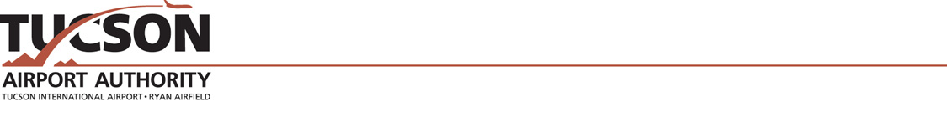

Request to film at Tucson International Airport (TUS) or Ryan Airfield (RYN)

Organization Name:

Contact Person:

Email:

Phone:

Mailing Address:

Please submit the following:

- Dates and times of filming at the airport.

- Purpose for filming at the airport.

- Briefly describe what activities will be filmed at the airport.

- Specific desired locations of filming at the airport.

- Identify any airlines/other airports that will be named or shown (if any).

Please also include:

- Number of people in your party including film crew, cast, and extras.

- List of equipment and props including vehicles that will be used.

- A copy of the script and proposed daily agenda.

Tucson Airport Authority
7250 South Tucson Blvd, #300
Tucson, AZ 85756
marketing@flytucson.com
520-573-8100

